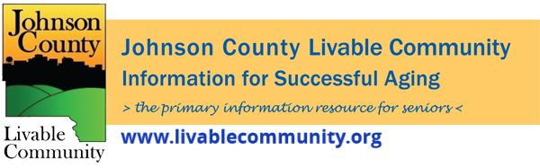

September 2021 Newsletter
In this month's issue:
- Falls Prevention Awareness Week
- Johnson County becomes an AARP Age Friendly Community
- New website
- Flu Vaccine Clinics
- Emergency Preparedness Month
- COVID-19 Scams
- Voter Registration Day
- Snow Removal
- LIHEAP
- UI National Advanced Driving Simulator Automated Vehicle
- Tai Chi for Arthritis and Fall Prevention
- Aging in Place: Reverse Mortgages
- Caregiver Wellness Series: Financial Preparation/ Options for Long-Term Care
- Local Programming
Falls Prevention Awareness Week
The 7th Annual Iowa Falls Prevention Coalition Symposium will take place September 20 through 24, during Falls Prevention Awareness week via Zoom. Iowans interested in falls prevention, such as family caregivers, health care practitioners, persons who work with older adults, students, and community members of all ages, should attend this free event!
TOPICS INCLUDE:
- Falls prevention within health systems; Medicare advantage programs.
- Motivating clients and patients to change their health-related behaviors.
- Assistive technology lending libraries across the state
- Tai Chi for Arthritis and Fall Prevention: Client pre- and post-testing methods
- Stepping On Fall Prevention Program: Overview and Iowa study
- The six Area Agencies on Aging will be providing information on their purpose and programming for elderly and disabled Iowans and their caregivers.
- Community services offered by rural pharmacists
- Caregiver tips for home modification, safe mobility in the home, and community safety
- Nutritional Requirements of the Elderly
- Medication De-prescribing/Home Meds Program
- Health assessment of an elder in their home: Tips and Best Practice
Visit https://uiowa.cloud-cme.com/course/courseoverview?P=5&EID=44227 for more information.
Questions can be directed to Kathleen Lee: kathleen-lee@uiowa.edu
Johnson County Becomes AARP Age-Friendly Community
Johnson County was recently recognized by AARP as an age-friendly community and was officially accepted into the AARP Network of Age-Friendly States and Communities. Johnson County is the first county to receive this designation in the State of Iowa.
The AARP age-friendly network challenges states, counties, cities, towns and rural areas to prepare for the rapid aging of the population of the United States. Communities are encouraged to focus on and strengthen features and services that help make communities livable for residents of all ages.
You can read the full press release at https://www.johnsoncountyiowa.gov/news/livable-community/2021-08-25/johnson-county-recognized-age-friendly-community-aarp-first

Livable Community Has a New Website
Johnson County Livable Community has a brand new website that is now part of the Johnson County website. You may still access it from the www.livablecommunity.org link.

Flu Vaccination Clinics
A reminder to get your flu shot. Contact your Physician, local pharmacy or attend one of the Visiting Nurse Association Flu Clinics: https://www.vnaic.org/annual-flu-shot-clinics

Emergency Preparedness Month
Written by: Travis Beckman, Deputy Director, Johnson County EMA
September is National Emergency Preparedness Month and with events still fresh on our minds such as the August 2020 Derecho and the current COVID-19 Pandemic, preparing for emergencies and disasters is more important than ever. Our most common topics often remind us that we should all Build a Kit, have a Communication Plan, and know our escape routes. But what about the times you are held up inside your home for long durations? Now imagine that scenario and the community is without electricity, and you or a loved one is on a medical device that requires constant and uninterrupted power supply. That is where our Johnson County Special Needs list can help both you and us. Registering your home address in our database allows for us to target special messaging before, during and after disasters. This database also serves as a list of those with needs that may require a welfare check during times of prolonged outages and other emergencies. Rest easier knowing that we know of your special need and can help our responders or care agencies with providing them this critical information during times of disaster. Whether you are oxygen dependent, on dialysis, or have limited mobility you can select those categories when you or your caregiver create your account and help us help you during an already difficult time. Provided services are evaluated at time of disasters and are not guaranteed. Please always have a back up plan.
Register here: https://www.smart911.com/smart911/ref/reg.action?pa=JohnsonCountyAlerts

COVID-19 Scams
Written by: Harrison March, Community Engagement Coordinator, Heritage Area Agency on Aging
Around 18 months into the COVID-19 pandemic in Iowa, it’s easy to feel like we’ve settled into something normal. There’s comfort in settling into this normalcy, but it’s no reason to let your guard down when it comes to scammers. They remain smart, quick and relentless in their pursuit of older Iowans. From fake charities in the early stages of the pandemic to faux vaccine registration in the winter, they’re evolving and adapting just like the rest of us.
While we continue learning what’s on the horizon of this pandemic – whether that will be safety measures, an additional vaccine dose for certain people or something entirely unforeseen – remember to be wary of strangers asking about money, valuables or your personal information. Keep these three pointers in mind:
- A government agency or vaccine provider will not charge you money, gift cards or anything of value to receive a vaccine. They may ask you to provide insurance information so that your insurer can be billed accordingly.
- Do not provide personal information to someone on the phone or the computer if they contacted you. The best practice is to hang up/close your internet browser, find the phone number of the organization that contacted you, and then contact them using the information you looked up. Remember that a Caller ID can be “spoofed,” meaning the caller can hide their true ID with a fake one from somewhere local.
- Scammers are tricky. They might manage to get information from you even when you do your best. When this happens, Heritage is here to help. Our Elder Rights team is in your corner every step of the way and can work with local law enforcement to help in your recovery. A phone call to Heritage is one you can trust: 319-398-5559 or toll free at 800-332-5934.
Remember these tips and pass them along to a friend or family member, too. Looking out for each other has never been more important. Slamming it to scammers is one more way we can pull together to keep our communities happy and safe. For more information on the Heritage Elder Rights Program, visit our website here.

Snow Removal
Nobody wants to talk about snow in September, but now is the time to plan ahead if you need assistance with having your driveway and sidewalks cleared of the white stuff. AbbeHealth Aging Services is currently accepting applications but has limited openings.
This service, which is very basic, is ideal for those who have physical disabilities, severe arthritis, neuropathy, heart conditions or other risk factors and cannot afford regular snow removal. For more information or to apply, please contact Aging Services at 319-398-3644.

LIHEAP
HACAP will start accepting applications for eligible individuals 60+ on October 1, 2021 for LIHEAP (Low-Income Home Energy Assistance Program). Check the HACAP website for eligibility guidelines and applications.

Seeking passengers to ride in automated vehicle
Want to ride in a partially automated vehicle? The University of Iowa National Advanced Driving Simulator is looking for people who:
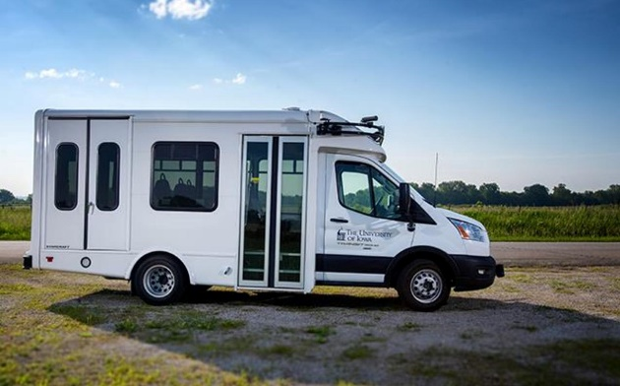
- Are age 65 or older or
- Are age 25 or older with a disability that affects their mobility or
- Are age 25 or older with low vision impairment
They’ll be making stops in Iowa City, Hills, Riverside, and Kalona and will be looking at riders’ perceptions of the technology. A safety driver will be behind the wheel at all times watching the road and can easily turn automations off (similar to how you turn cruise control off).
To learn more, visit ADSforRuralAmerica.uiowa.edu/participate or call 319-335-6803.

Tai Chi for Arthritis and Fall Prevention
If you are 65 or older or have a chronic health condition of any kind: Come join the UIHC sponsored Tai Chi for Arthritis and Fall Prevention program which will be held 2 days a week, on Mondays and Wednesdays, from 10:00 AM to 11:30 AM, each day for 8 weeks. These classes are held online via the University of Iowa Zoom platform . People under 65 may attend the class if they have any kind of chronic health condition.
The class runs from October 4-December 1.
This program has been shown to:
- Improve physical condition, muscle strength, coordination, and flexibility
- Provide low-impact, weight-bearing, aerobic exercise
- Improve balance and decrease the risk for falls
- Ease pain and stiffness
- Improve sleep
- Increase overall wellness
Visit https://www.eventbrite.com/e/tai-chi-for-arthritis-and-fall-prevention-tickets-166520510329 to learn more.
Aging In Place: Reverse Mortgages Ins & Outs
October 13, 2021 at 12PM
The equity in your home can help you pay for home modifications, at-home care, or other expenses. Reverse mortgages are one of the many products that help you tap into your equity, but often come with many questions. Get more information about the benefits and risks of this tool from John Gianola of Legal Aid and Alan Tenney of Mutual of Omaha.
Register to view via Zoom at http://bit.ly/Oct13-AIP-Reverse-Mortgages or view it live on Johnson County Social Services Facebook page.

Caregiver Wellness Series: Financial Preparation and Understanding Options for Long-Term Care
On October 12th at 1PM the presentation will be on financial preparation and understanding options for long-term care. The presenters will be Phyllis Zalenski, Iowa State University Extension & Outreach and Pam Railsback, Long-Term Care Ombudsman.
To learn more and to view the event visit: https://www.heritageaaa.org/cwd
Upcoming Caregiver Wellness Events
November 9th- Kathy Good and Abby Weirather from Family Caregivers Center of Mercy will present on caregiving experiences and strategies to combat social isolation during COVID-19. Bryan Bruner, Heritage Area Agency on Aging will provide a demonstration of Tai Chi for Older Adults.

Local Programming
AARP Iowa- Upcoming Events- https://states.aarp.org/iowa/iowa-events
Hancher Auditorium- Upcoming Events- https://hancher.uiowa.edu/upcoming-events
Iowa City Senior Center- September Calendar and Updates- https://www.iowa-city.org/WebLink/ElectronicFile.aspx?docid=2017443&dbid=0&repo=CityofIowaCity
North Liberty Senior 55+ Connections Lunch- Returning for in-person lunches and programming-Click the link for the calendar- https://northlibertyiowa.org/calendar/north-liberty-events/
Call (319) 626-5701 or by email agolly@northlibertyiowa.org
Stanley Museum of Art- https://stanleymuseum.uiowa.edu/events/
TRAIL of Johnson County- Their calendar features a curated collection of virtual public events (as well as those just for TRAIL members) that they select from local, regional, and national sources. That link is here: https://trailofjohnsoncounty.org/calendar

*THE JOHNSON COUNTY LIVABLE COMMUNITY NEWSLETTER IS A DIGITAL NEWSLETTER- THIS HAS BEEN CONVERTED TO A PRINTABLE FORMAT FOR ALL TO READ. PLEASE NOTE THAT MANY OF THE CLICKABLE LINKS WILL ONLY WORK WHEN VIEWED THROUGH A DIGITAL DEVICE.
TO SUBSCRIBE TO THE MONTHLY JOHNSON COUNTY LIVABLE COMMUNITY NEWSLETTER YOU MAY VISIT https://livablecommunity.us3.list-manage.com/subscribe?u=a9f307a3cbce1cc4ca622bb7f&id=d21460a2e3 or contact Jeff Kellbach at jkellbach@johnsoncountyiowa.gov

