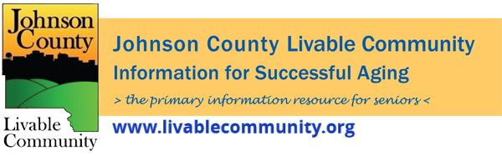

April 2022 Newsletter
In this month's issue:
- Earn- N- Learn Workshops
- 2nd Booster Dose
- Direct Assistance Program
- Double Up Bucks
- Fresh Conversations
- Social Security Office Update
- Spring Cleaning
- Battery Recycling
- Local Programming and News
Horizons Financial Wellness Center Earn-N-Learn Workshops
The Financial Wellness Center Earn-N-Learn Workshops cover Credit, Savings and Debt Management. This interactive presentation allows attendees to identify financial goals, discuss strategies to reduce expenses, plan for next steps, and plan for setbacks and set reminders for upcoming steps.
Each household that completes all 3 session in the quarter will receive $50. They can potentially earn an additional $30 by completing follow-up surveys!
Sign up online at https://horizonsfamily.org/fwcnews/
There will be a Zoom session as well as an in-person session held at the Health and Human Services Building, 855 S. Dubuque Street, Meeting Room 203, Iowa City, Iowa 52240.
In-Person at the Health and Human Services Building, Room 203 will meet on:
-Thursday, April 21 at 1PM- Credit Voyage
-Thursday, May 19 at 1PM- Savings Success
-Thursday, June 16 at 1PM- Debt Management
Zoom- Thursdays at 12PM on:
-April 14- Credit Voyage
-May 12- Savings Success
-June 9- Debt Management
2nd Booster Dose
Older adults—especially those with underlying medical conditions—and people with compromised immune systems are at higher risk of severe COVID-19, and are among those most likely to benefit from the additional protection of a second booster shot.
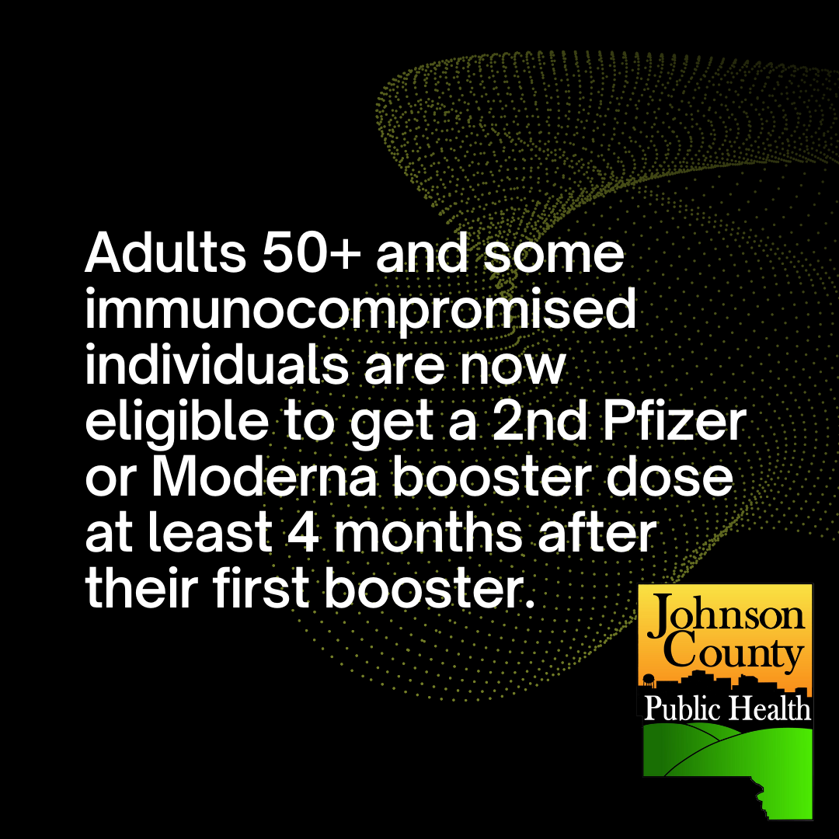
Direct Assistance Program
Johnson County's Direct Assistance Program provides one-time, financial assistance to eligible residents who have suffered hardship due to COVID-19. Applications for this program will open soon.
Eligible residents who are low- to moderate-income with documented hardship due to COVID-19 are invited to apply for a $1,400 emergency relief payment.
Applicants will apply online. Because the number of applications may exceed available funds, recipients will be chosen by random selection. Applying for the program does not guarantee that you will receive assistance.
For more information on this program visit: https://www.johnsoncountyiowa.gov/direct-assistance-program

Double Up Bucks Program
Double Up Food Bucks is in a variety of locations, including farmers markets and grocery stores. Here's how you can earn and spend Double Up Food Bucks to get free fruits and vegetables!
Step 1: Bring your SNAP EBT card to a participating location near you.
Step 2: For every $1 you spend on any fresh fruits and vegetables with your SNAP EBT card, you will get $1 in Double Up Food Bucks!
Step 3: Use the short videos and explanations below (specific to type of participating location) to help guide you through your purchase!
Step 4: Spend your Double Up Food Bucks right away or save for another visit. In 2021, Double Up Food Bucks will expire quarterly – check the expiration date on the bucks!
Participating locations in Johnson County include:
- Fareway Commerce Dr. – Iowa City - 2765 Commerce Dr., Iowa City, IA 52240
- Fareway Westwinds Dr. – Iowa City - 2530 Westwinds Dr., Iowa City, IA 52246
- New Pioneer Coop – Coralville - 1101 2nd St., Coralville, IA 52241
- New Pioneer Coop – Iowa City – 22 S. Van Buren St., Iowa City, IA 52240
- Iowa City Farmers Market – Iowa City - 405 E. Washington St., Iowa City, IA 52240
- Local Harvest CSA- Solon- 5025 120th St. NE, Solon, IA 52333

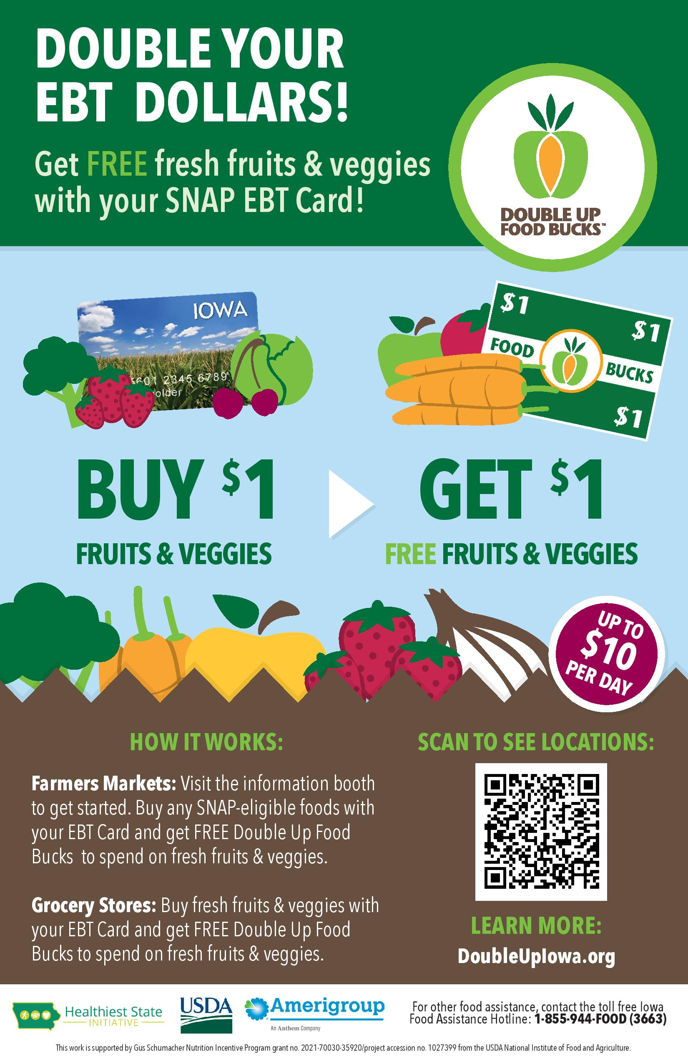
Fresh Conversations
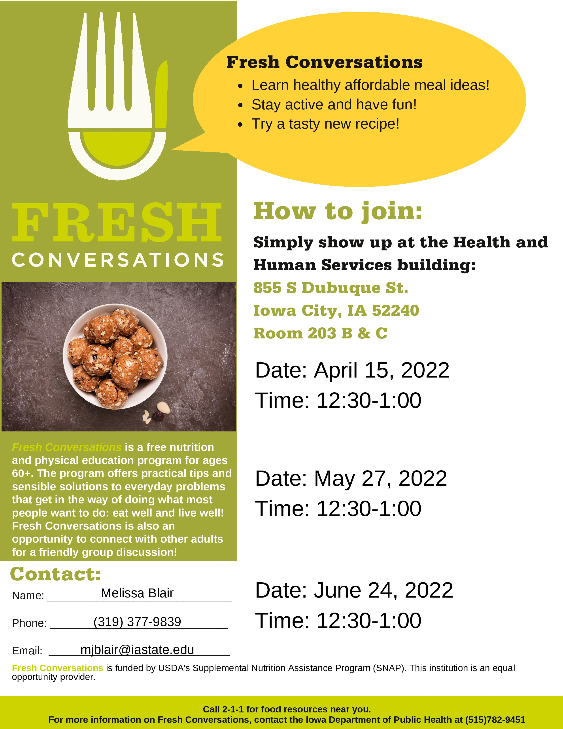
Social Security Office Reopening
Beginning Thursday, April 7th the Coralville Social Security Office is restoring in-person services, including for people without an appointment. The Coralville office is located at 1100 6th Street Suite 100, Coralville, IA 52241.
Online and phone services remain available at www.socialsecurity.gov and by phone at 1- 866-964-2039.

Spring Cleaning
Although the weather is not fully cooperating it is officially Spring and thus time for Spring cleaning projects. As you look to clean out your home of clothes, household goods and furniture consider ways to avoid having these items ending up in the dump! In Johnson County there are so many options to donate or consign. Iowa City Moms put together a comprehensive list of places in this article available at https://iowacity.momcollective.com/2022/03/04/where-to-donate-and-consign-in-the-iowa-city-area/?fbclid=IwAR2Yh-1Ykj7cz3cxQ7Eiq6pt-MkXODGB8EjxiHaToE89-nX6KQ3WH1WtfdE

Battery Recycling
Since 2020, the Resource Management Division at the landfill, which serves all of Johnson County, has safely and properly recycled nearly 4,000 pounds of alkaline batteries and over 800 pounds of rechargeable batteries. With the expansion of the program in 2020 to include alkaline batteries and additional drop-off locations in the Iowa City area, rechargeable battery recycling has increased by 15%.

Why you shouldn’t throw batteries in the trash
When a battery ends up in the trash and eventually makes its way to the landfill, heavy equipment that compacts trash can damage the battery. A damaged battery can spark and ignite a fire or release hazardous material into the landfill or environment. In 2021 there were 12 battery fires, so the Resource Management Division is raising awareness of the need for safe disposal of batteries from common uses such as cell phone and medical equipment batteries.
Residents of Johnson County and the cities of Kalona and Riverside can recycle single-use (such as alkaline) and rechargeable (such as lithium-ion) batteries at no cost at the drop-off locations listed below. (Details on the each location’s hours of operation and where to leave the batteries can be found here).
- Hazardous Material Collection Facility, 7 a.m. to 2 p.m., Thursdays, Fridays and Saturdays, 3900 Hebl Ave. SW, Iowa City
- Fire Station #2 West, 301 Emerald St., Iowa City
- Ace Hardware East, 1558 Mall Drive, Iowa City
- Ace Hardware North, 600 N Dodge St., Iowa City
- Iowa City City Hall, 410 E Washington St., Iowa City
- Coralville Recreation Center, 1506 8th St., Coralville
- North Liberty Community Center, 520 W Cherry St., North Liberty
Damaged batteries or large batteries (such as lead-acid batteries) should be taken to the Hazardous Material Collection Facility at the Iowa City Landfill, 3900 Hebl Ave. SW.
A sincere thank partners at the local Ace Hardware stores, Iowa City Fire Department, and Cities of Coralville and North Liberty for helping to reduce battery fires and protect our environment. City staff also thank the Iowa Department of Natural Resources for their grant funding and outreach support via the statewide “Take Charge” battery education program.
For more information on when and where you can recycle batteries, check out www.icgov.org/hhm.
Questions? Contact the Recycling Coordinator at jane-wilch@iowa-city.org or at 319-887-6110.
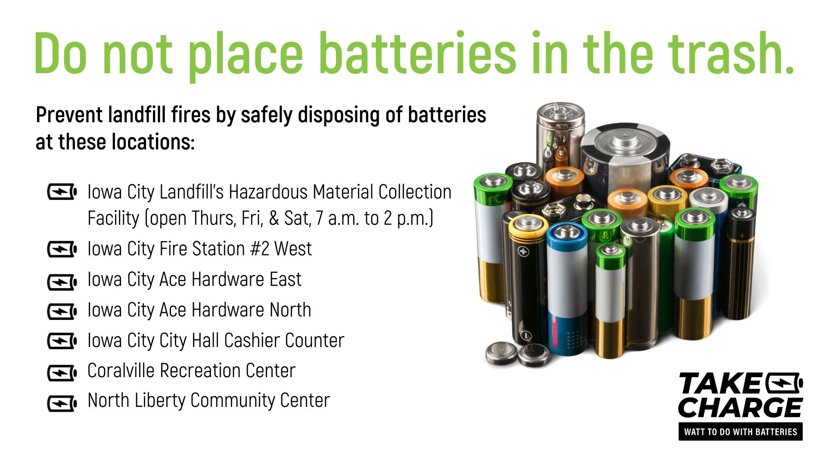

Local Programming & News
AARP Iowa- Upcoming Events
Alzheimer's Association- Upcoming Events and Support Groups
COVID Recovery Iowa- Facebook Group Silver Linings
Hancher Auditorium- Upcoming Events
Iowa City Senior Center- March and April Program Guide
North Liberty Senior 55+ Connections Lunch- In-person lunches and programming- Click here for the calendar. Call (319) 626-5701 or email agolly@northlibertyiowa.org
Stanley Museum of Art- Click here for their website.
Solon Senior News- Click here for their April Newsletter
TRAIL of Johnson County- Their calendar features a curated collection of virtual public events (as well as those just for TRAIL members) that they select from local, regional, and national sources. That link is here: https://trailofjohnsoncounty.org/calendar
UI Center for Human Rights- Upcoming Events

*THE JOHNSON COUNTY LIVABLE COMMUNITY NEWSLETTER IS A DIGITAL NEWSLETTER- THIS HAS BEEN CONVERTED TO A PRINTABLE FORMAT FOR ALL TO READ. PLEASE NOTE THAT MANY OF THE CLICKABLE LINKS WILL ONLY WORK WHEN VIEWED THROUGH A DIGITAL DEVICE.
TO SUBSCRIBE TO THE MONTHLY JOHNSON COUNTY LIVABLE COMMUNITY NEWSLETTER YOU MAY VISIT https://livablecommunity.us3.list-manage.com/subscribe?u=a9f307a3cbce1cc4ca622bb7f&id=d21460a2e3 or contact Jeff Kellbach at 319-688-5842 or by email at jkellbach@johnsoncountyiowa.gov

