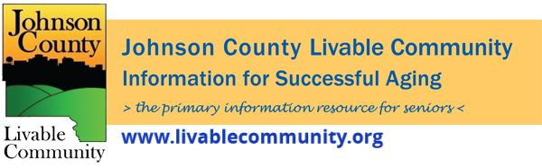

Older Americans Month Programming
- Older Americans Month 2022
- Disaster PrepWise Program
- Heart Healthy Webinar
- Home Modifications for Aging in Place
- Transportation Options for Older Adults in Johnson County
- Medicare 101
- AARP Fraud Prevention
- National Nursing Home Week
Older Americans Month 2022
May is Older Americans Month(OAM) and this year's theme is "Age My Way."
Johnson County includes a growing number of older residents who enrich our community through their diverse life experiences. The County is committed to strengthening our community by connecting with and supporting older adults, their families, and caregivers and acknowledging their many valuable contributions to society.
Thank you to the Johnson County Board of Supervisors for recognizing Older Americans Month with the reading of a Proclamation at their April 28, 2022 Formal Meeting.
Johnson County Livable Community (JCLC) is a resource available to all in Johnson County. JCLC's mission is to serve as a unifying structure that fosters effective collaboration, communication, and education that will build and sustain a livable community for successful aging.
See the flyer and events listed below or go to www.johnsoncountyiowa.gov/older-americans-month or call 319-356-6090 for more information.
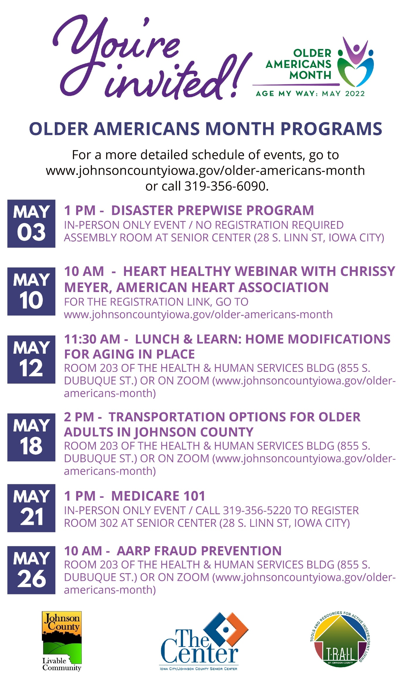
Disaster PrepWise Program
May 3rd at 1PM
Disaster PrepWise (DPW) is an emergency preparedness program developed by the University of Iowa College of Public Health that consists of five interactive modules and two additional sections on special topics.Through engaging in discussions about disaster preparedness and management, a trained interventionist enters participants’ information into the online tool to develop a personalized disaster management plan.
The five modules are:
1. Complete a Personal & Household Assessment
2. Develop a Personal Emergency Network
3. Develop Emergency Information & Gather Important Documents
4. Keep a 3-5 Day Supply of Medications & Medical Supplies
5. Build an Emergency Supply Kit
This program is supported by the the Senior Center,University of Iowa, Johnson County Public Health, and TRAIL of Johnson County.
In-Person Only Event- Iowa City Senior Center, 28 S. Linn St., Iowa City, IA 52240 in the Assembly Room.
No Registration for this event.
Heart Healthy Webinar
May 10th at 10AM
Chrissy Meyer, Communications Director American Heart Association
Heart health is possible at any age! Join us for a webinar presented by the American Heart Association to learn more about the 7 simple ways you can take control of your heart health for a longer, healthier life.
Zoom Event- Registration Link: https://us02web.zoom.us/webinar/register/WN_yCyshROsS4yu5XbDbw2wPQ
Home Modifications for Aging in Place LUNCH & LEARN
May 12th at 11:30AM
Lorraine Bowans, Senior Resource Specialist – LivWell Seniors & Senior Real Estate Specialist
During this hybrid event, learn ways to modify your home to make it safer and more accessible to everyone.
If attending in-person and you would like a lunch please e-mail Jeff Kellbach at jkellbach@johnsoncountyiowa.gov or call 319-688-5842 by 12pm on Monday, May 9th. The event will be held in Room 203 of the Health and Human Services Building, 855 S. Dubuque St., Iowa City, IA 52240
Home Modifications for Aging in Place CONTINUED
We are also offering a Zoom option with the event slated to start at 12pm. The Zoom registration link is https://us02web.zoom.us/webinar/register/WN_KzxahndgRhClzwL22Og38A
Transportation Options for Older Adults in Johnson County
May 18th at 2PM
Kelly Schneider, Mobility Coordinator Johnson County Social Services
Let’s talk about local resources for getting around the community without a personal vehicle during his hybrid event
Available In-Person in Room 203 of the Health and Human Services Building, 855 S. Dubuque St., Iowa City, IA 52240. No registration required for attending in-person.
We are also offering a Zoom option but registration is required at the following Zoom Registration Link: https://us02web.zoom.us/webinar/register/WN_U7H-d_7wSLiMq-Ijq3856w

Medicare 101
May 21st from 1-3PM
Roger Jensen & Bob Lower, Senior Health Insurance Information Program (SHIIP) Counselors
This two-hour seminar provides an overview of Medicare Part A and Part B benefits, the prescription drug benefit (Part D), Medicare Advantage plans, and Medicare supplement insurance. SHIIP, the Senior Health Insurance Information Program, is a service of the State of Iowa. SHIIP counselors are trained by the state and do not sell or promote any insurance companies, policies, or agents. The Center is a local sponsor for SHIIP in Johnson County.
Register online or call 319-356-5220
In-Person Only Event that requires registration- Iowa City Senior Center, 28 S. Linn St., Iowa City, IA 52240 in Room 302

AARP Fraud Prevention
May 26th at 10AM
Sally Leme, PhD, AARP Fraud Watch Speaker & Volunteer Network
The AARP Fraud Watch Network has been established to arm Americans with tools to spot and avoid fraud and scams. The Network educates, serves as a resource, and acts as watchdog in order to help individuals recognize and avoid fraud.
Hybrid Event- In-Person- Room 203 of the Health and Human Services Building, 855 S. Dubuque St., Iowa City, IA 52240. No registration necessary for attending in-person.
We are also offering a Zoom option but registration is required at the following Zoom Registration Link: https://us02web.zoom.us/webinar/register/WN_VL4blJYfSV6S4xSFwzfJgQ

National Nursing Home Week
National Nursing Home Week will be celebrated May 8-14, 2022 and this year's theme is “Creating and Nurturing Connections.”

Windmill Manor is hosting a Color Walk, Run or Roll on Saturday, May 14th at 9am with check-in beginning at 8am. For more information on this event that will benefit a local charity go to https://windmillmanor.com/colorwalkrunorroll.htm
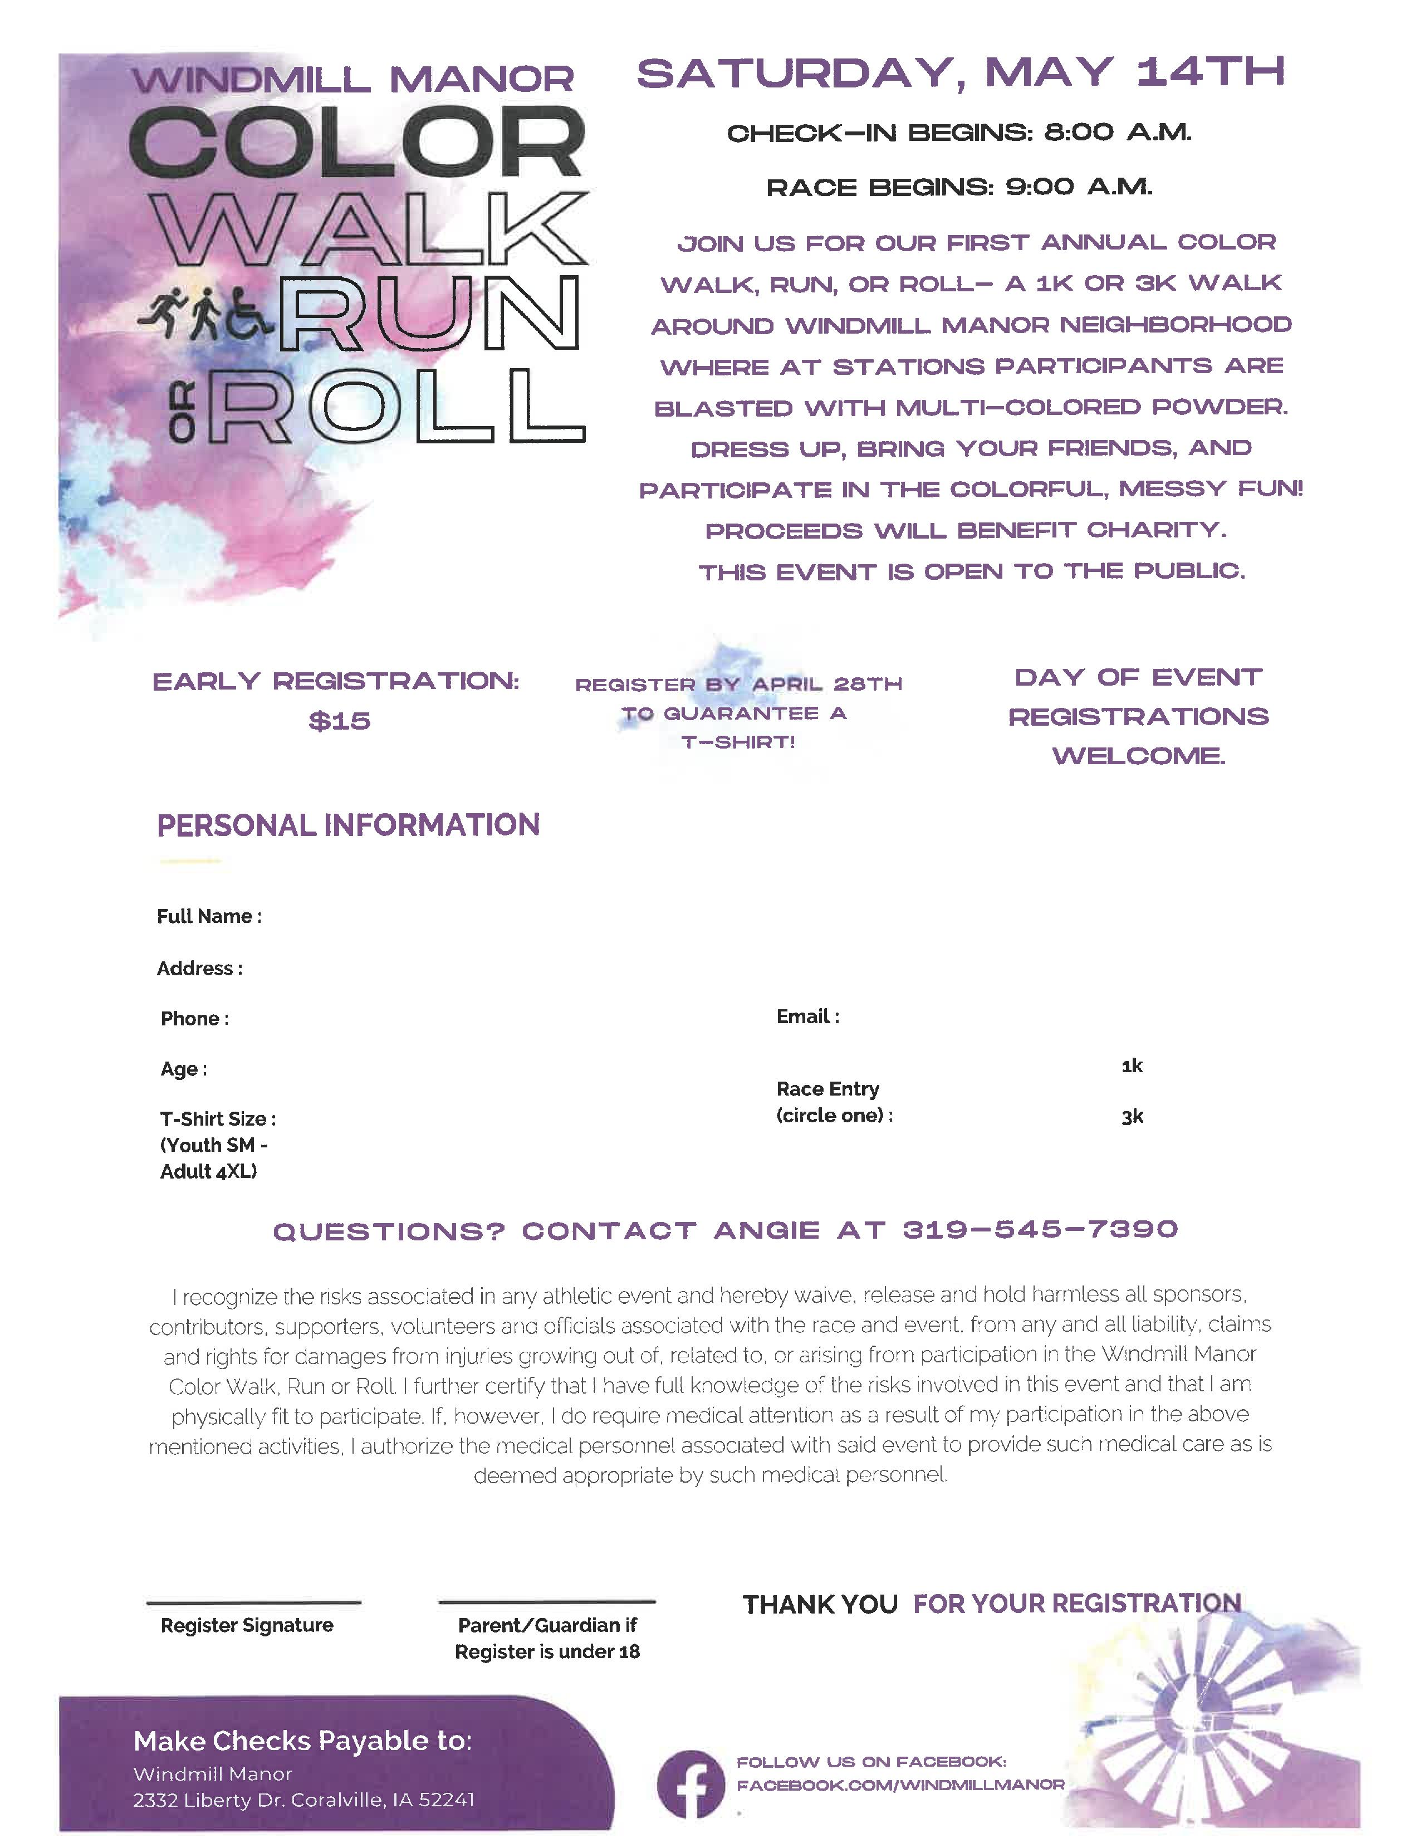

*THE JOHNSON COUNTY LIVABLE COMMUNITY NEWSLETTER IS A DIGITAL NEWSLETTER- THIS HAS BEEN CONVERTED TO A PRINTABLE FORMAT FOR ALL TO READ. PLEASE NOTE THAT MANY OF THE CLICKABLE LINKS WILL ONLY WORK WHEN VIEWED THROUGH A DIGITAL DEVICE.
TO SUBSCRIBE TO THE MONTHLY JOHNSON COUNTY LIVABLE COMMUNITY NEWSLETTER YOU MAY VISIT https://livablecommunity.us3.list-manage.com/subscribe?u=a9f307a3cbce1cc4ca622bb7f&id=d21460a2e3 or contact Jeff Kellbach at 319-688-5842 or by email at jkellbach@johnsoncountyiowa.gov

